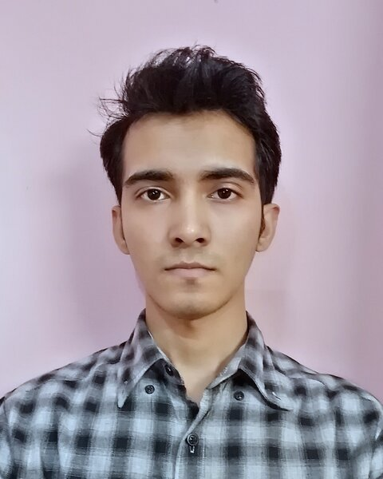

CURICULUM VITAE

**FAZLUL AYAN KOUSHIK**

**CONTACT**

114/4(2nd Floor), West Agargaon

Sher-E-Bangla Nagar, Dhaka-1207, Bangladesh

01791454825, 01515620305

[kf.ayan17@gmail.com](mailto:kf.ayan17@gmail.com)

<https://www.linkedin.com/in/fazlul-ayan-koushik-76935719b/>

**PROFILE**

To lead responsible position where I could use my interpersonal skills, creativity and above all of my learning experience in order to develop my skills, career and as well as to contribute in the welfare of the organization. I always hungry for knowledge and always inspired by something good. I’m well listener and self-motivated.

I like to play cricket, I can sing well, Have good knowledge about acting, I always entertain my friends.

**OBJECTIVES**

* Providing service for the organization through pro-activity and self-motivation.
* Providing potentiality through working successfully in under pressure.
* To obtain a meaningful and challenging place that enables me to discover and allows for progression.
* Finding out new efforts to increase overall financial growth of the company

**SKILLS**

001-home.png

067-phone.png

391-mail4.png

**LANGUAGE PROFICIENCY**

**LANGUAGE PROFICIENCY**

202-sphere.png

032-book.png016-camera.png

006-pencil.png018-music.png